Bill of Material for CMPE242

Harry Li, Spring 2016

|  |  |  |
| --- | --- | --- |
| Items | Description | Note |
| Sensor: Electric Compass and accelerometer LSM303 (I2C interface) | Use for sensor interface project | I2C (LSM303, HMC5883L, HMC6352) interface, see Appendix A |
| OpAMP: LM324 Quad Amp | OpAmp for preprocessing circuit | Use for analog sensor interface design circuit |
| POT | Resistive potential meter 4.7K ohm | Use for ADC interface testing |
| Red LED | 8-10 mA | For ExINT testing |
| Wall mount DC adaptor | 7.5VDC 500 mA or above | For prototype board power |
| RJ45 connector |  | For prototype board use |
| Wire wrapping board | 2x2 size or bigger |  |
| HS65SB or HS-645MG Servo | Ultra torque servo | For HS-645MG Current Drain (6.0V): 9.1mA/idle and 450mA no load operating $18.99; or Micro servo from Adafruit, $5.95 |
| Or Stepper motor and stepper motor driver board | Small stepper motor with current not exceeding 200 mA |  |
| Glue logic, resistors, capacitors, wires, switches, etc. |  |  |

Appendix A. Reference Parts

1. Electric Compass and Accelerometer: LSM303DLHC, from Adafruit, IIC interface, $14.95, <https://www.adafruit.com/products/1120> This board/chip uses I2C 7-bit addresses 0x19 & 0x1E. Software reference (for Arduino) <https://github.com/adafruit/Adafruit_LSM303>

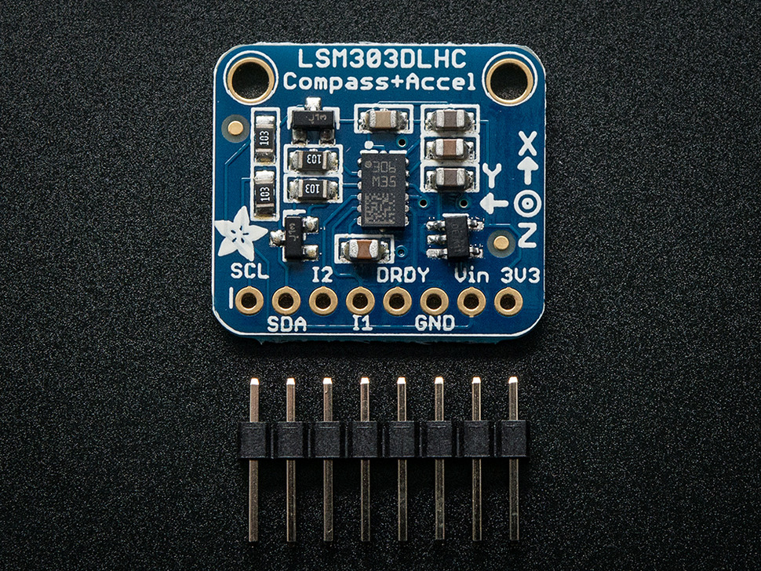

Figure 1. Electric Compass and Accelerometer, from Adafruit, $14.99, IIC interface.

1. Electric Compass: <https://www.adafruit.com/products/1746> from Adafruit, IIC interface.

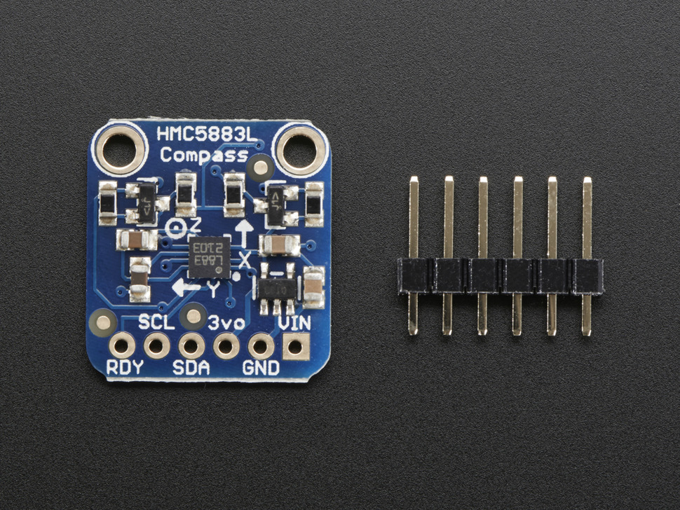

Figure 2. HMC5883L, $9.95.

1. Electric Compass: <https://www.sparkfun.com/products/retired/7915>, from Spark Fun, IIC interface, $149.

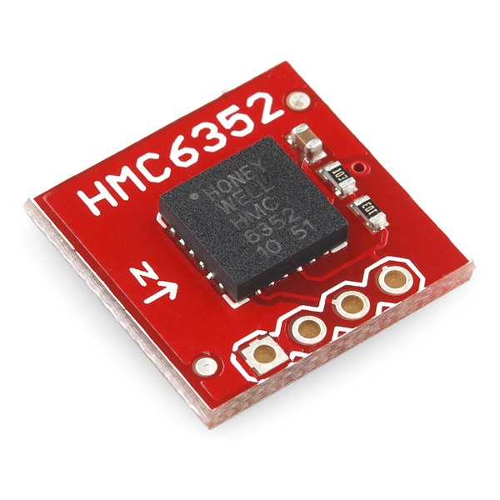

Figure 3. The sensor from Spark Fun.

1. Electric servo

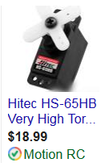

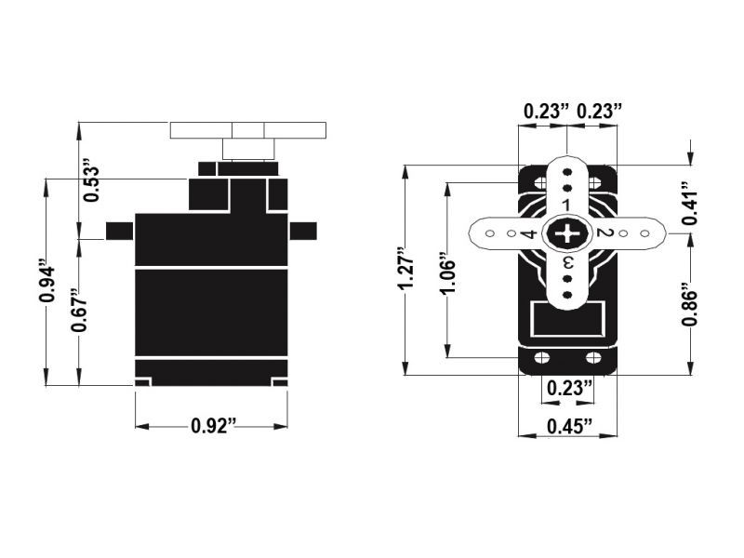

Figure 4. Servo <http://www.motionrc.com/hitec-hs-65hb-very-high-torque-9g-micro-servo/?gclid=COvy8L7V3MoCFc1ffgoda7UPkw>

Or from adafruit

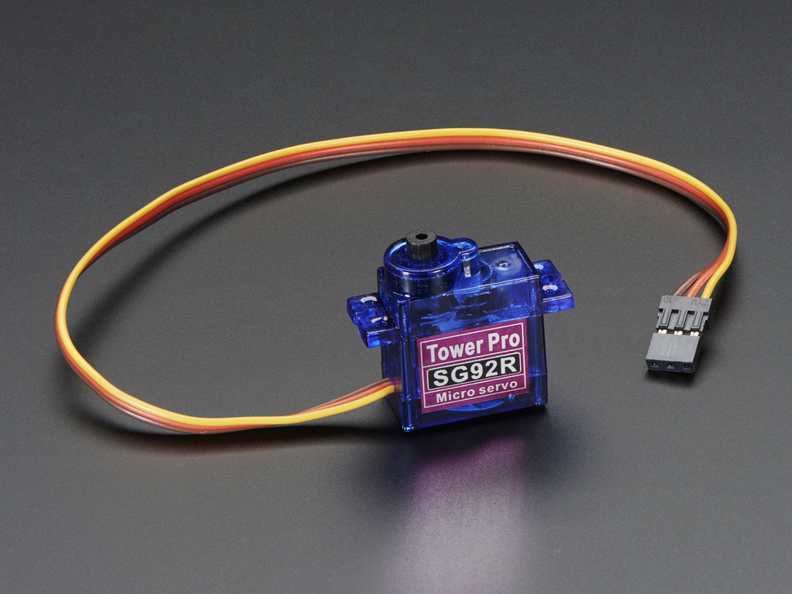

Figure 5. <https://www.adafruit.com/products/169?gclid=CIbAm4PX3MoCFYVbfgod6OcAog> $5.95 from Adafruit.

(END)